**Project background**

Design of STR -SNP markers. The marker is designed by linking the SNPs in the flanking region of the STR sequence located within ~200 base pairs (bp) upstream or downstream (Wang et al., 2013; Zhang et al., 2020).

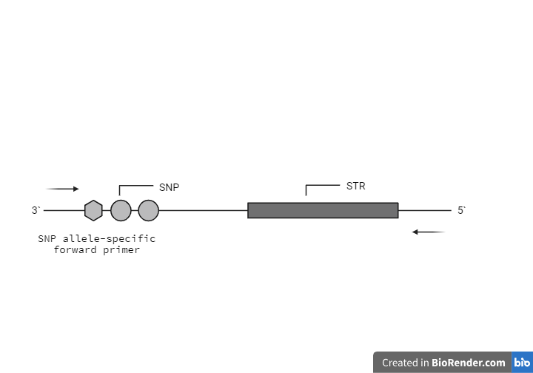

**Figure 1:** SNP-STR Compound Marker

**Specific research questions and objectives**

**Objectives**

1. To mine STRs discriminatory (polymorphic) for the African population
2. To identify SNPs neighbouring the STRs (SNP showing a minor allele frequency in the African population higher than 0.15).
3. To identify if the SNPs are associated with phenotypic traits (hair, eye, skin colour etc.)

**Methodology**

Mining STR data from public domain databases such as Pop.STR, 1000 Genomes, STRBase, etc. and identifying neighbouring SNPs

**Do you have any preliminary data/results?**

No

**Up to 3 important literature references**

1. Jian, H., Wang, L., Lv, M., Tan, Y., Zhang, R., Qu, S., Wang, J., Zha, L., Zhang, L., & Liang, W. (2021). A Novel SNP-STR System Based on a Capillary Electrophoresis Platform. Frontiers in genetics, 12, 636821. https://doi.org/10.3389/fgene.2021.636821
2. Kim, J., Rosenberg, N.A. Record-matching of STR profiles with fragmentary genomic SNP data. Eur J Hum Genet 31, 1283–1290 (2023). https://doi.org/10.1038/s41431-023-01430-9
3. Yu Tan, Hui Wang, Tao Feng, Li Wang, Weibo Liang, Lin Zhang, Developing eight SNP-STR markers for DNA mixture detection, Forensic Science International: Genetics Supplement Series, Volume 6, 2017, Pages e351-e352, ISSN 1875-1768, https://doi.org/10.1016/j.fsigss.2017.09.114.

**How experienced are you with using the command line and/or R?**

No experience

**How confident are you in running the analysis yourself?**

It could work if a specific code is provided to fetch data

**Do you have a data management plan?**

Data will be stored at the genetics department, UKZN. All data generated will be made available after publication in peer-reviewed journals.

**What is your budget for bioinformatic support?**

Will be decided based on the number of hours required